The Prince William - Fauquier Voter

Fall 2023 Newsletter

**From the President:**

**LWV September-October**

**Our October kickoff meeting was postponed due to the windy, rainy aftermath of a hurricane, but the work went on in our busiest months, September and October. We are replanning a holiday get-together for Sunday, November 19, at the Bull Run Library.**

**Nov. 7 is an important election for us in Virginia because so much of what we do is educate and explain to voters who is running, what’s at stake and where and when one can vote. In an off-off year with many candidates for various local offices, our information tools like Vote411 and Top Tens are vital.**

**Volunteer coordinator Judy Hingle tells me we staffed 32 events, including 7 libraries, 8 high schools, new teacher orientations, senior residence assistance and a mental health awareness session in addition to Fall festivals in Haymarket, Vint Hill, Manassas (x3) and Dale City. PWFA volunteers have assisted the Arlington chapter with new citizen registration at ceremonies with the USCIS.**

**Our Voter Services leaders Carol Proven and Laura Feld-Mushaw, with a big assist from Carol Noggle, provide materials and relay banners and tables around our large geographic area for all of these events.**

**A special shout out to our Fauquier Unit Chief Barbara Amster for organizing “So You Are 18” programs in three county high schools with the local Bar Association. She persisted for years to make this happen and the Bar is already down for continuing. By the registration deadline Oct. 16, we registered more than 250 new voters. Despite reminders from teachers to bring their Social Security number that day, dozens of students took the form home to reconnect with their number. We have volunteers who swing by the high schools a few days after these events to pick up belatedly completed forms at the school office.**

**We have a long way to go to match Taylor Swift’s call for her fans to register that brought in 35,000 new voters on National Voter Registration Day. But if every LWV chapter was as active as we have been, we are competitive.**

**Our Advocacy Director Carol Noggle is keeping a wary eye on the governor’s questionable activities on restoration of felons’ right to vote. Virginia is one of a few states that limit voting access after a felony conviction. Former felons are permanently disenfranchised here unless Governor Youngkin restores their civil rights in a process that continues to be opaque. A recent “purge” of the voting rolls dropped 10,588 voters due to a software error, according to election officials, who say they have brought the number down to 270. Both Virginia U.S. senators have asked the U.S. Department of Justice to investigate this action, which took place during the voting period for a consequential Assembly election.**

**Thanks to all for volunteering your time and skills to fulfilling our mission.**

**Pat Reilly**

**Notes from the Treasurer, Trish Freed**

**Did you miss paying your dues this summer? If so, support our League and all the good**

**we do by paying now.**

**Click to d****ownload the flyer here.**

**If nothing has changed, and you want to pay by PayPal,**

**﻿or by credit card, click below to pay directly.**

**Donate (paypal.com)**

Support our Education Fund also, by making a tax-deductible donation. Our Education Fund provides our local league with revenues that support our voter outreach activities, whether they be tabling events at community fairs, candidate debates, or preparation of our Top Ten handouts. As always, we appreciate your support.

﻿

To make a **tax-deductible donation to the Education Fund via your credit card click here:****Donation to LWV Education Fund VA-116**

**Or, you can send a check payable to the LWV Education Fund and note our League ID VA 116 in the Memo line. Mail to: LWV-Prince Willia**



This Photo by Unknown Author is licensed under CC BY-SA-NC

**The LWV-PWFA is looking for volunteers! Please consider how you may be of service to your local league and your community. Help is always needed in voter registration events at local high schools. Members who prefer the comfort of their own homes are needed to highlight handouts, fold documents and help plan events. How about leading one of the book discussions? Even if you simply share ideas about speakers, good venues for meetings, or topics for Sips & Civility, you are considered a volunteer.**

**For more information on volunteering please reach out to Judy Hingle, jkhingle@gmail.com, or any of the Board Members!**

Voter Information

**Same Day Voter Registration**

- Janet Boyd, Voter Service Chair, LWV-VA

 Virginia has “same day voter registration”, which allows you to vote and register at the same time.

**During Early Voting:** Between October 17 and November 4, 2023, go to your local registrar’s office or any early voting site. These can be found at https://vote.elections.virginia.gov/VoterInformation/PublicContactLookup by using the dropdown box to find your local city/county.

**On Election Day, November 7**: go to your own voting site, which you can find at our nonpartisan voting information website https://www.vote411.org/.

Bring one of the forms of Identification needed to vote in Virginia, which can be found here: https://www.elections.virginia.gov/registration/voterid/.

Once there, you will be allowed to register to vote and file a provisional ballot. You must register and vote at the same time. Provisional ballots are used by voters who do not appear on the list of registered voters at their polling location. Provisional ballots are approved by your local elections board once they are assured that you are eligible to vote and have only cast one ballot.  You will receive notice of when the Board will review your ballot, you may attend but are not required to. You will receive written notice if your ballot is rejected.

For questions on this contact your local registrar.

If you feel someone is trying to stop you from voting, contact this non-partisan **Election Protection Hotline  866-OUR-VOTE (****866-687-8683****). THIS IS AVAILABLE IN SEVERAL LANGUAGES.**

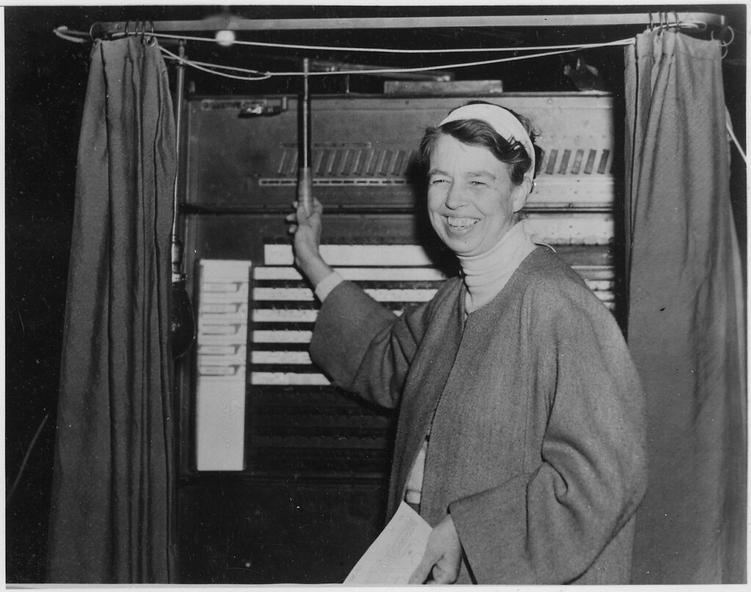Eleanor Roosevelt voting in 1936, less than twenty years after the Nineteenth Amendment guaranteed women the right to vote.

*FDR Library Photo*

Looking back on her political development, Eleanor Roosevelt wrote that she had her “first contact with the suffrage movement rather late.” In fact, she did not consider herself a suffragist until 1911, when her husband Franklin D. Roosevelt, then a state assemblyman in New York, came out for women’s right to vote. “I realized that if my husband were a suffragist I probably must be, too.”

It was only in the 1920s that Eleanor Roosevelt became fully involved in the women’s rights movement. Soon after moving back to New York City after the 1920 presidential election, Roosevelt became a board member of the New York State League of Women Voters and began to direct the League of Women Voters’ national-legislation committee. By mid-decade Roosevelt played a central role in a network of women who led New York’s most influential organizations; including the League of Women Voters, the Women’s Trade Union League, the Women’s Division of the New York State Democratic Committee, and the Women’s City Club. She was particularly drawn to the social feminists of the League of Women Voters and the labor feminism of the Women’s Trade Union League. These alliances led to Roosevelt's interest in the poor and working-class women, and legislation designed specifically to protect women in the workplace.

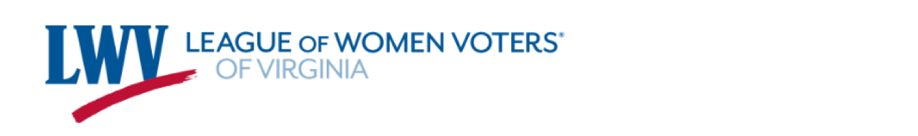

**News from the State League:**

**Pre Session is December 6, 2023**

Mark your calendars and RSVP now for our 2023 Pre Session which will be a  
virtual event. Pre Session is when we bring in our partner organizations to  
have them present their legislative priorities for the 2024 General Assembly  
Session. Invited guests include:

* Susan Beals, Commissioner, Virginia Department of Elections
* Stephen E. Cummings, Secretary of Finance, Commonwealth of Virginia
* Narissa S. Rahaman Executive Director, Equality VA
* James W “Jay” Speer, Executive Director, Virginia Poverty Law Center

There will be more than 20 partners in attendance.

 We will continue to update you when we get a full agenda. Secure your spot

today: RSVP **here**

**We Have a Podcast!**

The League of Women Voters of Virginia Presents: **Confessions From The Voting Booth Podcast**

With a League that takes pride for being Issue Driven and Party Blind; every month Denise Harrington (LWV-VA, State Advocacy) and Candi Bradshaw (LWV-VA, State Social Media) are teaming up to talk about the top priorities on the voting list that need to be acknowledged by our government and state candidates. It's time to hold them accountable.

**Podcast Link:** https://open.spotify.com/show/7zazIL4QFfjtvr5wf4eiVx?si=73bfd2d2d5d54bd9

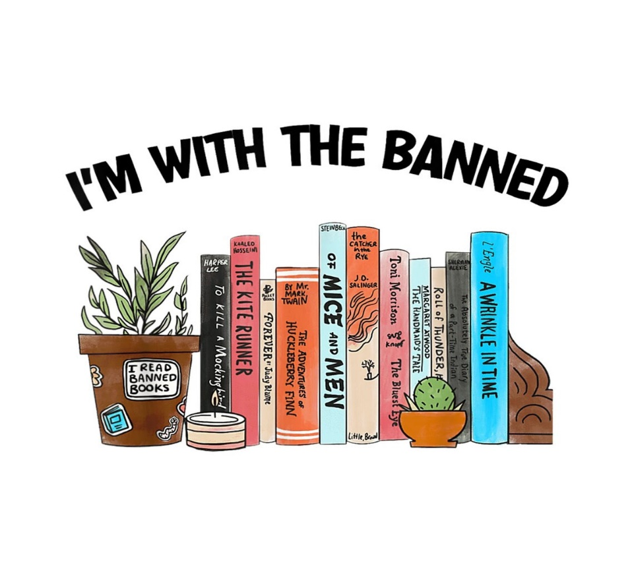

Banned Books Week was October 1 – 7, 2023.

Banned Books Week serves not only to celebrate literature that disrupts comfortable thinking but also the very first idea that the founders of the United States of America added to our Constitution: The First Amendment. In asserting the freedom of speech to every person, our founders held sacred the notion that no one should be prevented from expressing or consuming ideas that others may find objectionable. Books that fall on the lists of banned or challenged books demonstrate the attempt by some to silence an author from expressing their ideas, their lived experience, their imagination. Bans and challenges also attempt to thwart the freedom of readers to explore the same ideas, experiences, and imaginings.

In 2023, the State League delivered 350 "vote" flyers to the Virginia Library Association for use during "Banned Book Week" Oct 1 – 7. Various LWV members made an amazing video that was used by us and the Association during Banned Book Week! This is the long version, which will be on Youtube - and we have six 2 minute pieces that will be boosted through social media by us and the Virginia Library Association.  The theme this year is "Let Freedom Read". Check it out **here**!

|  |
| --- |
| Now with all of that being said, LWV-PWFA has a member who comments are part of the video. Connie Gilman, a past Virginia Library Association President, sent in her recording of her favorite banned book, Are you there God? It’s me Margaret, by Judy Blume. Connie felt compelled to be a part of the video because of her strong support of the Freedom to Read movement. In addition, it was the first book she was challenged with as a junior high school librarian. During that encounter, she learned her voice was heard because she was prepared to uphold her views. And, much to her surprise, she wasn’t totally intimidated by the principal! |

|  |  |
| --- | --- |
| |  | | --- | |  | |

|  |
| --- |
|  |

|  |  |
| --- | --- |
| |  | | --- | |  | |

**Library Story Time**

Voter Education Project Report

Chair Janet Gorn

September provided an innovative opportunity for the LWV-PWFA League to cohost with the Prince Willliam library a Story Time Voter Education Project, aimed at both children and adults, in six (6) libraries (Dumfries Library; Dale City Library; Potomac Library; Central Library; Chinn Park Library;

and Haymarket Gainesville Library). Four LWV-PWFA member volunteers, with a wiggle and a giggle from future voters, cohosted a total of 78 children and 83 adults. The Sesame Street Cookie Monster and students from the Monster, Inc. University joined the group for a short time. The

League designed the events to reach out to a unique demographic voter niche, the parents and childcare givers attending the Prince William County Library Story Time. The Story Time voter education program reviewed the election process and promoted the importance of voting and advocacy for an issue, in particular censorship and the closing of a library. All were enlightened while volunteers read the related children’s book the “Monster Needs Your Vote” by Paul Czajak, and distribution of a children’s educational coloring, activity, and story book: Do Your Part and Vote. The Prince William County Library on October 7 released a YouTube video of the “Monster needs Your Vote” Story Time along with promoting voting on Election Day November 7.

Bader Ginsburg U.S. Postage Stamp

U.S. Postal Service just issued a postage stamp in honor of U.S. Supreme Court Justice Ruth Bader Ginsburg. The stamp costs $0.66 each or $13.20 for a sheet of 20 stamps.

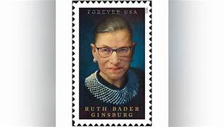Justice Ruth Bader Ginsburg was appointed as the 107th U.S. Supreme Court Justice serving for 27 years dedicating her life to public service as an engineer of the legal fight for women’s rights. The stamp comes at a time when those hard-won rights are under attack. The Justice was a true pioneer and left an incredible legacy in support of equal rights for women. This stamp serves not just as a tribute but as an inspiration for our current generation and for future generations to uphold the values she fought for that are the bedrock of the LWV policies.

**WVUS LOBBY Corps Report**

By Janet Gorn, Legislative Affairs Representative, LWVUS U.S. Congress Lobby Corps Delegate, LWVUS Delegation to the United Nations Commission on

the Status of Women

After three years of COVID-19 restrictions, the LWVUS Lobby Corps is back advocating LWV policy positions before the U.S. Congress. To protect Americans’ rights, League civic participation is imperative. Lobbying is an important part of our Democracy. LWV members need a strong voice on Capitol Hill. LWV advocacy liaison on the Hill is welcomed; nonpartisan, researched and factual information is harder for Congressional staff to find. The purpose of the U.S. Congressional Lobby Corps is to: 1) Educate U.S. Congressional Staff about pending legislation, 2) Increase the League’s influence on Capitol Holl, 3) Promote and communicate the League’s priorities, and 4) Empower LWV state and local leaders to engage in national advocacy. The Lobby Corps works with the LWVUS Advocacy staff on specific lobbying assignments once per month and about eight or nine months per year. The Lobby Corps consists of about a dozen League legislative affairs who represent the entire LWV, including state and local leagues across the United States. The

LWV Corps representatives receive assignments to advocate for select members of Congress, The representatives visit new members and reelected Congressional members on both sides of the aisle, building relationships.

The LWVUS also maintains international advocacy as a United Nations Observer Corps to the UN Commission on the Status of Women. Role includes monitoring UN Programs and as delegates to the UNCWS fall and spring conferences, as well as the CSW67 Conference (in person and zoom events). Dr. Connie Sobon Sensor, PhD, RN, CTN-A, ‘Assistant Professor, Rutgers University, is the LWVUS Chief NGO Representative to the United Nations. The NGO-CWSNY League is responsible for monitoring events and programs.

The LWVUS Board of Directors sets the lobbying agenda based on the current “Impact on Issues” policy positions for both the U.S. Congress and the United Nations Commission on the Status of Women. For the U.S. Congress, currently and for 2024 spring the League is focusing on protecting our voting rights, in particular through advocacy for the “Protecting Our Democracy Act”. For the UNCSW, the League is focusing on the newly established “Global Youth Fellows Program” sponsored by Youth Leaders and Young Professionals.

Janet Gorn, LWV-PWA Liaison

The LWV-PWFA League is a member of the League of Women Voters of the National Capital (LWV-NCA) area. It is an Inter-League Organization (ILO), an integral part of the League of Women Voters of the United States (LWVUS), and is consistent with the Bylaws and governing policies of the LWVUS. LWV-PWFA membership is also consistent with the LWVUS Transformation Plan to increase consideration of regional and interjurisdictional issues. The purpose of the LWVCNCA is to promote political responsibility through informed and active participation in government, and to act on selected governmental issues of a metropolitan, regional, or inter-jurisdictional nature.

Current membership includes: 1) LWV of the District of Columbia (LWVDC), 2) Virginia [LWV of Virginia (LWV-VA); Arlington and Alexandria City (LWVAR); Fairfax Area (LWVFA); Falls Church (LWVFC); Loudoun County (LWVLC); Prince William and Fauquier Area (LWV-PWFA)]; and 3) Maryland [LWV of Maryland (LWVMD); Frederick County (LWVFR); Howard County (LWVHC); Montgomery County ((LWVMC); Prince George’s County (LWVPGC)]

FY-2023-2024 dues are minimal and far outweigh the benefit of membership. Approximately a little more than $1 per member and less than $100 of the budget.

LWV-PWFA Liaison serves as the Chair of the Bylaws Committee and is a member of the Fund-Raising Committee (Concert).

Planning for the Biennium 2023-2025 is in the early development stages. Membership has many positive benefits: 1) Monthly exchange of league member activities, 2) Discussion of regional or intergovernmental issues and development of an advocacy action Plan, 3) Income from Fund Raising Event (approximately four figures), 4) access to Grant opportunities, and 5) opportunities to partner with other leagues.

Of particular current interest to LWV-VA leagues is the LWV-NCA consideration of the important *Regional Greenhouse Gas Initiative* (RGGI), which affects all the NCA members.  On January 15, 2022 Virginia Governor Glenn Youngkin signed Executive Order Number Nine: “Protecting Ratepayers from the Rising Cost of Living Due to the Regional Greenhouse Gas Initiative.” The Order directs Virginia re-evaluate Virginia’s participation in the RGGI and immediately begin regulatory process to end it.

The LWV-VA Advocacy Chair hit the ground running with a *Call to Action*. The Call referenced recently adopted policy position at the 2023 Convention on *Environmental Justice* (See *Positions for Actions* 2023).   Of particular importance is the point:

*Furthermore, a* *letter* *that 61 legislators have already sent to the Air Pollution Control Board states, "Virginia’s participation in RGGI is mandated by law. Therefore, ultimately only a change in the law that passes both chambers of the General Assembly and is signed by the Governor can remove Virginia’s participation.” Attempts to circumvent the law will end up in court costing taxpayers.*[Executive Order # 9, Revision 22]

The LWV-PWFA Board responded by sending out a special Constant Contact *Call to Action* message to all members.

|  |  |  |  |  |  |  |  |  |  |  |  |
| --- | --- | --- | --- | --- | --- | --- | --- | --- | --- | --- | --- |
| |  |  |  |  |  |  |  |  |  | | --- | --- | --- | --- | --- | --- | --- | --- | --- | | |  | | --- | |  | |  | |  | |  | |  | | --- | |  | |  | |  | | | | |
|  |
| |  |  |  | | --- | --- | --- | |  |  |  | | |

**League Meetings are open to all members!**

Board of Directors Meeting, 3rd Tuesday of the month, 7:00-9:00 pm

**LWV-PWFA Website**: www.princewilliamlw.org

**LWV-PWFA Email**: lwvpwfa@gmail.com

|  |  |  |  |  |  |  |  |  |
| --- | --- | --- | --- | --- | --- | --- | --- | --- |
| |  | | --- | |  | |  | |  | |  | |  | | --- | |  | |  | |  | |

**2023-2025 Board of Directors**

**Officers:**

President                            Pat Reilly

Vice President                   Kim McCusker

Recording Secretary        Barbara Greiling

Treasurer                          Trish Freed

**Directors:**

Voter Services Co-Directors         Laura Feld-Mushaw & Carol Proven

Volunteer Director                             Judy Hingle

Membership Records Director         Jane Touchet

Membership Outreach Director       Catherine Ring

Advocacy Director                   Carol Noggle

Events Coordinators Cynthia Chambliss & Sheila Arrington

|  |  |  |  |  |  |  |  |  |
| --- | --- | --- | --- | --- | --- | --- | --- | --- |
| |  | | --- | |  | |  | |  | |  | |  | | --- | |  | |  | |  | |

Please send in ideas for the Winter 2024 Newsletter by January 20. Better yet, submit an article, send some photos, ask some questions, or share a joke!

Connie Gilman, Newsletter Chair, conniewg51@gmail.com