 “The Prince William - Fauquier Voter”

July 2023 Newsletter

**Welcome to the new Biennium and to our new Officers and Directors!**

**2023-2025 Board of Directors**

**Officers:**

President                            Pat Reilly

Vice President                   Kim McCusker

Recording Secretary        Barbara Greiling

Treasurer                          Trish Freed

**Directors:**

Voter Services Co-Directors         Laura Feld-Mushaw & Carol Proven

Volunteer Director                             Judy Hingle

Membership Records Director         Jane Touchet

Membership Outreach Director       Catherine Ring

Action/Program Director                   Carol Noggle

Meeting Co-Directors                         Cynthia Chambliss & Sheila Arrington

Non-elected:

Ex-Officio Officer       Janet Gorn

***PLEASE MEET….***

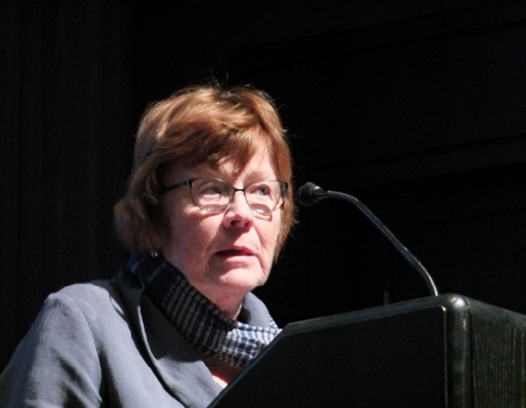Pat Reilly, the incoming president of the Prince William-Fauquier Area! Formerly, Pat served as the Media Relations adviser to the board.She was a newspaper reporter and editor for 20 years, at *The Washington Post, New York Newsday* and other regional newspapers. She has been a spokesperson and webcontent manager for enforcement units at the U.S. Environmental Protection Agency and the Department of Homeland Security. She has a master’s degree in journalism from Ohio University and a bachelor’s in education from Truman University in Missouri.

Pat has extensive experience running a non-profit, Friends of Liberia, which has done international development work in Liberia for more than 30 years. She was a Peace Corps volunteer there in the ‘70s. She is a former chairman of the board of the National

Peace Corps Association, the alumni organization for the U.S. Peace Corps.

After retirement from government in 2011, Pat joined the board of Solas Nua, a non-profit

organization dedicated to showcasing contemporary Irish art. She directed the annual

Capital Irish Film Festival from 2015-2023, bringing the best in Irish cinema to the D.C.

metropolitan area. Originally from New Jersey, she has lived in Marshall, Fauquier

County, for 20 years. She enjoys reading and water yoga.

|  |  |  |  |  |  |  |  |  |  |
| --- | --- | --- | --- | --- | --- | --- | --- | --- | --- |
| |  |  |  |  |  |  |  |  |  | | --- | --- | --- | --- | --- | --- | --- | --- | --- | | |  | | --- | |  | |  | |  | |  | |  | | --- | |  | |  | |  | | |

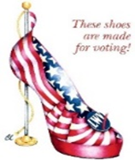**The 2022-2023 Annual Report**

from Past President, **Janet Gorn**

Clearly the LWV-PWFA Board of Directors reached beyond its grasp and

accomplished much in the 2022-2023 Fiscal Year to achieve a robust, successful

program. The Board also strengthened its administrative Toolbox, by updating

its Bylaws and adopting Standing Rules, as well as adopting and updating various

Policy Guides, and revising the Board of Directors Handbook. Having expanded its membership in the 2021-2023 Biennium to include two (2) counties, increasing its political footprint, in both Prince William County and Fauquier County, by encouraging active citizen participation in government, working to increase understanding of major political issues, and influencing public policy through education and advocacy activities, the League of Women Voters of the Prince William-Fauquier Area, provided much added value to the LWV Mission.

To increase the League’s membership, the League developed a recruitment program, “Each

One Bring One,” including a promotion plan, with something to fit every member’s calendar

and every member’s interests. The plan included flyer distribution, news media ads, a color

trifold brochure about our activities, “Why Join the LWV” palm cards, and recruitment

posters at community events. The year ended with a total membership of eighty (80).

The League expanded and developed a more robust media coverage of LWV-PWFA League through photos, fact sheets, press releases, etc. throughout the community, along with the monthly Constant Contact, and the website. The League highlighted the importance of its founding with a quarter page color birthday ad in the Prince William Times on its February 14th birthday.

The League believes “Informed Citizens are Engaged Voters.” To that end, in the Voter

Education area, the LWV-PWFA league partnered with the Committee of 100 by cohosting

candidate fora. In 2022, the league cohosted a candidate forum for the 10th Congressional

District, and in 2023 for the Gainesville District Prince William Board of Supervisors Special

Election. In addition, the League engaged citizens through distribution of the “VOTE411” pre-

election guide, “Top Ten” government information and “Facts for Voters”.

Member Education benefited from joining the Book Review Group and broadening views on

issues of interest through reading both contemporary and previously published books. Meeting

speakers and monthly webinars expanded member issue education e.g., PWC Plastic Recycling;

Elected representative experience in the Virginia General Assembly; PWC Environment and

Energy Sustainability; Piedmont Environment Council and Land Use Data Bank activities;

Responsibility of the new PWC Environment and Sustainability Office; and book banning and

censorship. The League also benefitted as a member of the National Capital Area League (NCA)

on broader regional issues of interest in Virginia, Maryland, and D.C.

The League conducted its “Know your Local Government” activities, through the LWV-PWFA

Government Observer Corps, tracking agenda, attending meetings, etc. The League also

organized two local Issue Study Committees to review and develop a proposed LWV-PWFA

Policy Position: 1) the Prince William County 2040 Comprehensive Plan and 2) the Prince William

County Racial and Social Justice Commission Report. In addition, the LWV-PWFA has a

volunteer participant on all four of the LWV-VA State Level Issue Study Committees [Money in

Politics, Environmental Justice, Education Equity, Child Care]. The LWV-PWFA League similarly

left its footprint at the United Nations Commission on the Status of Women, CSW-67 Meeting;

President Janet Gorn was appointed as a member of the LWVUS Delegation to the CSW-67. The

President was also appointed to the LWVUS Lobby Corps and is participating in the full range of

League advocacy activities with the U.S. Congress.

The LWV-PWFA continued conducting its long-standing robust Voter Registration Program

throughout the Prince William and Fauquier area. During the school year, the League

organized high school voter registration and partnered with the Prince William and

Fauquier Bar Associations’ “So You’re 18: Legal Rights and Responsibilities” presentation, for all

county high schools, conducted by State certified League volunteers. This resulted in more

than 2,000 registered students by the end of the school academic year. The voter registration

program has expanded to NOVA Community Colleges, senior facilities, National Voter

Registration Day in selected libraries, and participation at 10 community events.

The League’s Community Outreach Program included: sponsoring the Delta Sigma Theta

Sorority Martin Luther King, Jr. annual Oratorical Contest by presenting each of the six finalists

with a book; coalition sponsorship in the Black Lives Matter weekly vigil in Warrenton, Va.;

and sponsorship of the Prince William County Re-Entry Council. The League also partnered with

the Prince William and Fauquier libraries with author and book signing events; Campaign for

Woman Suffrage in Virginia, and a Sips and Civility Interactive Traveling Exhibit Event and

presentation “We Demand Women Suffrage in Virginia”.

Last, but not least, the League President submitted a letter to the “Letters to the

Editor” column of the Washington Post and a Guest Column to the Prince William Times, on Governor Younkin’s lack of transparency in changing Virginia policy on restoring civil rights to felons.

The League ended the Fiscal Year on a high note at its Biennium Meeting with a presentation by

the Keynote Speaker Delegate Eileen Filler-Corn, who greatly increased our knowledge of

General Assembly activities on policy issues of interest, and the “glass ceiling” challenges to

women’s leadership.

|  |
| --- |
|  |

|  |  |  |  |  |  |  |  |  |  |
| --- | --- | --- | --- | --- | --- | --- | --- | --- | --- |
| |  |  |  |  |  |  |  |  |  | | --- | --- | --- | --- | --- | --- | --- | --- | --- | | |  | | --- | |  | |  | |  | |  | |  | | --- | |  | |  | |  | | |
| Notes From Treasurer Trish Freed  The FY 23-24 Membership Drive is in full swing! If you haven’t already renewed  your membership, please do so now. We will be present at many community events in Prince William and Fauquier Counties this summer and fall, registering voters and handing out important voting information. Please join us in our mission to:  **Empower Voters and Defend Democracy**  To access the membership renewal form, please click on the following link  [Membership Form 2023-2024](https://view.officeapps.live.com/op/view.aspx?src=https%3A%2F%2Fwww.princewilliamlwv.org%2Fwp-content%2Fuploads%2F2023%2F05%2FLWV-PWFA-Membership-Form-2023-2024-3-8-23.docx&wdOrigin=BROWSELINK) (Hold the “Ctrl” key at the same  time as you click on the link). Please choose the membership category and  payment method of your choice, per options on the form.  If paying by check, please make it payable to: LWV-Prince William-Fauquier  Area, and mail to: Treasurer, LWV-Prince William-Fauquier Area;  6151 Hemlock Court, Manassas, VA 20112.  We also welcome tax-deductible donations to our Education Fund.  This can be done via your credit card. Here’s a link to the website: [Donation](https://form.jotform.com/201055595959163?league=VA116)  [to the LWV ED Fund VA 116.](https://form.jotform.com/201055595959163?league=VA116) |
| |  |  |  |  |  |  |  |  |  | | --- | --- | --- | --- | --- | --- | --- | --- | --- | | |  | | --- | |  | |  | |  | |  | |  | | --- | |  | |  | |  | | |
| **May 21, 2023Biennial LWV-Prince William and Fauquier Area Meeting**   |  |  | | --- | --- | | |  | | --- | | **We had an excellent meeting at Manassas Park Community Center (many thanks to Jea﻿nette Rishell, Mayor and longtime League member). The keynote speaker was Delegate Eileen Filler-Corn, the first woman in 400 years to be Speaker of the House! We had a brief business meeting (voted on the budget and new officers), tea, wonderful desserts, and a most enjoyable afternoon with Del. Filler-Corn, who spoke of her experiences in the General Assembly. She emphasized how bi-partisan support is necessary to get work done in the Assembly, and how she was committed to across-the-aisle cooperation. After the meeting she answered questions posed by the members.**  **Delegate Filler-Corn sent a thank you letter, which you can read below.**  **Dear Miriam, Laura, Janet, and Deb:**  **Thank you for inviting me to your meeting and for providing an opportunity to discuss the path forward in Virginia with your members. I especially appreciate your kind words of support for my efforts.**  **I wanted to follow up with some information about my work as the first woman and the first person of Jewish faith to ever serve as Speaker of the Virginia House of Delegates. As you know, during my time as Speaker,**[**we made great strides in improving access to the ballot box.**](https://www.nytimes.com/2021/04/02/us/politics/virginia-voting-rights-northam.html)**Among these reforms were the creation of same-day voter registration and a permanent mail-in absentee voter list. Because of our success,**[**Virginia moved from the second hardest state to vote to the 12th easiest**](https://newsroom.niu.edu/how-hard-is-it-to-vote-in-your-state/)**. I am also including**[**a link to a recent video chronicling my service in Virginia.**](https://www.youtube.com/watch?v=OtTFBBOnFFw)  **Please do not hesitate to contact me if I can ever be of any assistance.**  **Sincerely yours,**  **Eileen**  **--**  **Delegate Eileen Filler-Corn**  **56th Speaker of the Virginia House of Delegates**  [**571-249-3453**](tel:571-249-3453) | | |
| |  |  |  |  |  |  |  |  |  | | --- | --- | --- | --- | --- | --- | --- | --- | --- | | |  | | --- | |  | |  | |  | |  | |  | | --- | |  | |  | |  | | |

**Biennial Conference Mixes Business with Fascinating Speakers**

written by Pat Reilly

Preserving Democracy in the 21st Century was the theme of the LWV-VA 41st Biennial

Conference, which was appropriately held in Williamsburg on June 3 and 4, 2023. Eighty-eight

delegates represented 14 chapters from around the state. Each chapter gave a lively

report on their activities in the Roll Call opening. Prince William-Fauquier Area chapter

had three representatives: Carol Proven, Carol Noggle and Pat Reilly.

This was the final convention as president for Deb Wake (Fairfax). She received kudos

for a job well done and welcomed as the new president Joan Porte (Arlington-

Alexandria City), who had served as first vice president for several years.

The assembly overwhelmingly voted to accept new and updated positions, which are

the result of years-long study by groups, that involved Child Care (updated), Education

Equity, Environmental Justice, and Money in Politics. For details on these positions see

Positions and Studies – League of Women Voters of Virginia (lwv-va.org)

A proposal by Carolyn Caywood to the Resolutions Committee was recommended to

the full body and approved. It involved transparency in government, specifically that all

branches of Virginia government must respect the public’s right to know by doing public

business in public. It resolved that a state Transparency Issue Group work with local

Observer Groups to ensure government bodies do their business in the open.

The convention wasn’t all business. Special speakers included Provost Peggy

Agouris, Chief Academic Officer, William and Mary University, who welcomed the

League as a partner in areas of mutual concern, such as voter access.

The Saturday lunch speaker, Brenda Andrews, president and owner of *The New Journal*

*and Guide*, Virginia’s oldest Black weekly newspaper, described the vital role of the

Black press in ensuring awareness of Black perspectives in the nation’s history. She

warned of the current challenges to the survival of the press in general and the Black

press in particular.

Professor A.E. Dick Howard, the Warner-Booker Distinguished Professor of

International Law at the University of Virginia, was the honored speaker at Saturday’s

dinner. As a young attorney chosen to be on a special commission to rewrite the

Virginia Constitution in 1971, he was tasked with drafting the document that would

guarantee Black voting rights and eliminate such racist artifacts as the poll tax and

literacy tests. He then went on to lead the campaign to get the Constitution ratified. He

was a chief consultant to Governor Terry McAuliffe’s efforts to restore rights to returning

felons who had served their time. Professor Howard has consulted on the writing of constitutions around the world.

On Sunday morning, the convention heard from Kimberley Hundley, a teacher who

became a member of the Williamsburg-James City County School Board. She told the

gathering about how she applied her experiences as an educator to the work of

overseeing a school system.

Before adjourning, the convention approved the slate of officers and board members,

who, with President Joan Porte, will lead the LWV-VA going forward. To learn more

about them, go to lwv-va.org/lwv-va-board-of-directors-candidates-biographies-2023/

An underlying theme of the convention was “get involved.” Whether it’s running your

chapter or joining a study group, the League runs on individuals committing to the work.

|  |  |  |  |  |  |  |  |  |  |  |
| --- | --- | --- | --- | --- | --- | --- | --- | --- | --- | --- |
| |  |  |  |  |  |  |  |  |  | | --- | --- | --- | --- | --- | --- | --- | --- | --- | | |  | | --- | |  | |  | |  | |  | |  | | --- | |  | |  | |  | | | |
|  |  |

**Fauquier County Juneteenth Ce**l**ebration**

Reported by Ruthann Litchford

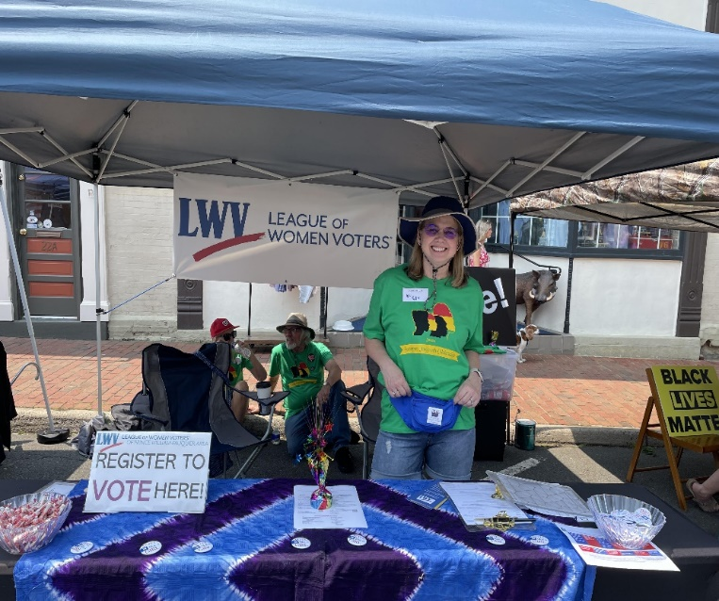

It was a full day and the crowds were impressive.  Though we only completed a single paper registration that does not reflect how effective our presence was.

We handed out nearly 100 Top Tens that addressed only the few voting precincts that had primaries on June 20th.

The low number of registrations we facilitated (paper & online) was due to the vast majority of attendees already being registered and, if in a primary district, had already voted.  This day was packed with folks ready to have their voices counted.

(Miggy Strano in photo)

We were able to hand out two Restoration of Rights information and applications.

And we were visited by at least three candidates for the general election. They all spent time talking and asking questions about the League and all took our literature and put on buttons.

Buttons were a hit again.  I do see them being worn around town and that's always Top of Form

Bottom of Form

|  |  |  |  |  |  |  |  |  |  |
| --- | --- | --- | --- | --- | --- | --- | --- | --- | --- |
| |  |  |  |  |  |  |  |  |  | | --- | --- | --- | --- | --- | --- | --- | --- | --- | | |  | | --- | |  | |  | |  | |  | |  | | --- | |  | |  | |  | | |

**“Health Equity Day" at Freedom High School**

|  |  |  |  |
| --- | --- | --- | --- |
| Reported by Carol Noggle |  |  |  |
| Members Laura Feld-Mushaw, Brenda Carswell, Sheila Arrington, and Carol Noggle attended the “Health Equity Day” organized by the Delta Sigma Theta (DST) sorority. | | |

DST provided excellent information with speakers in the school library on several topics. Some young people were there to get certain required physical exams. Pat Victorson of NAMI made a presentation on mental health. Members attended the training on narcotic (fentanyl) overdoses and the use of Narcan. Attendance at the session certified them as being trained to recognize the need for emergency care and how to administer Narcan properly.  Participants each received a box with 2 doses of Narcan.

Attendees also received a bag of very healthy food including a large jar of spaghetti sauce, pasta, chicken/veggie patties, fruit juice, and macaroni & cheese.

Many of the DST members were wearing red. They are very interested in having our Red "VOTE: Democracy is not a Spectator Sport" shirts. They have plans to do in-person outreach to voters for upcoming elections.

The Election Office provided two handouts. One was a 5x8-inch card that had election information on one side and election officer recruitment information on the other side. They also provided their 8x11- inch handout for recruiting election officers.  The need is for officers for November.

We did not sign up anyone to register to vote, but I was not surprised. We did provide the two usual handouts -- "Who Represents you NOW?" and the list of all the races and candidates for the Primary. I think the attendees were well-informed prior to the meeting.

After working two Early Voting days, however, as an election officer at Haymarket Library, it is clear that many voters are not well-informed on the process of a dual primary or on all the races.

|  |  |  |  |  |  |  |  |  |  |
| --- | --- | --- | --- | --- | --- | --- | --- | --- | --- |
| |  |  |  |  |  |  |  |  |  | | --- | --- | --- | --- | --- | --- | --- | --- | --- | | |  | | --- | |  | |  | |  | |  | |  | | --- | |  | |  | |  | | |

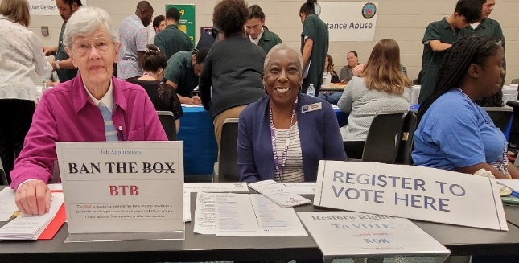Carol Noggle and Brenda Carswell attended the Resource Fair held for inmates – with felon or misdemeanor charges or convictions-that was sponsored by the PW Adult Detention Center. This fair is held to help those incarcerated to discover resources that are available to them upon their release.

|  |  |  |  |
| --- | --- | --- | --- |
| |  |  |  | | --- | --- | --- | |  |  |  | |

|  |  |  |
| --- | --- | --- |
| |  |  | | --- | --- | | |  | | --- | |  | | |

|  |  |  |  |  |  |  |  |  |  |  |  |
| --- | --- | --- | --- | --- | --- | --- | --- | --- | --- | --- | --- |
| |  |  |  |  |  |  |  |  |  | | --- | --- | --- | --- | --- | --- | --- | --- | --- | | |  | | --- | |  | |  | |  | |  | |  | | --- | |  | |  | |  | | | | |
|  |
| |  |  |  | | --- | --- | --- | |  |  |  | | |

***WELCOME NEW MEMBERS!***

|  |  |  |  |
| --- | --- | --- | --- |
| |  |  |  | | --- | --- | --- | | |  |  | | --- | --- | | |  | | --- | | Lyssa White (former member, just rejoined)   [lyssawhite@gmail.com](mailto:lyssawhite@gmail.com)  Annette Durand Fiddler   [annettefiddler1948@gmail.com](mailto:annettefiddler1948@gmail.com)  Kim McCusker   [kimmccusker@gmail.com](mailto:kimmccusker@gmail.com)  Jennifer Coates   [jencoates41@gmail.com](mailto:jencoates41@gmail.com)  Paula Patrick   [paulapat2@gmail.com](mailto:paulapat2@gmail.com) | | | |

|  |  |  |  |  |  |  |  |  |
| --- | --- | --- | --- | --- | --- | --- | --- | --- |
| |  | | --- | |  | |  | |  | |  | |  | | --- | |  | |  | |  | |

**Mark Your Calendars**

|  |  |
| --- | --- |
| |  | | --- | | **It is time to take the Training for Voter Registration**  Every year we are required to take the training for voter registration. Whether it is in high schools or at an event, the training is required. You can visit the website [**Virginia Department of Elections - Registration Drive Training**](https://www.elections.virginia.gov/registration/registration-drives/) and take the online training, or if you prefer, choose to attend an online meeting.  After training, be sure to submit the [**Third Party Voter Registration Form (formsite.com)**](https://fs28.formsite.com/vaelect/3rdpartyvoterreg/index.html)**.**  Once you have done that, sign up and participate in the Dale City 4th of July Parade and Family Fun Day! Put your training to work, interacting with the citizens at Dale City.  [**LWVPWFA: July 4th Dale City Parade and Family Fun Day Mentored Voter Registration Opportunity (signupgenius.com)**](https://www.signupgenius.com/go/9040c4aadae2aab9-july7/35417392#/) | |

|  |
| --- |
|  |

|  |  |
| --- | --- |
| |  | | --- | |  | |

|  |  |  |  |  |  |  |  |  |
| --- | --- | --- | --- | --- | --- | --- | --- | --- |
| |  |  | | --- | --- | | |  | | --- | |  | |  |  | | --- | |  | | |  | | --- | |  | | |  |  | | --- | --- | | |  | | --- | |  | | |

|  |
| --- |
|  |

|  |  |
| --- | --- |
| |  | | --- | |  | |

**League Meetings are open to all members!**

Board of Directors Meeting, 3rd Tuesday of the month, 7:00-9:00 pm

(No Board Meeting in November and December)

General Meetings and Events, 3rd Sunday of the month, 2:00-4:00 pm

**LWV-PWFA Website**: <www.princewilliamlwv.org>

**LWV-PWFA Email**: [lwvpwfa@gmail.com](mailto:lwvpwfa@gmail.com)

Please send any comments or concerns to Connie Gilman, Newsletter Editor, [conniewg51@gmail.com](mailto:conniewg51@gmail.com).